Business Summary

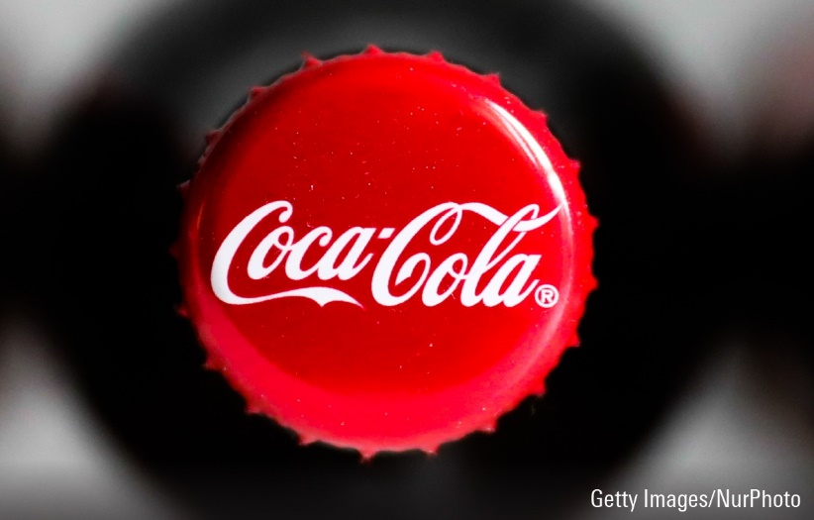

**COCA-COLA**

Coca-Cola is one of the world's leading beverage companies, with a history dating back to 1886 when it was first invented by Dr. John S. Pemberton. Over the years, the company has expanded its product line to include a variety of non-alcoholic beverages, including sparkling drinks, juices, sports drinks, and teas.

Coca-Cola has kept up its expansion and growth over the last 10 years. The business generated $33.01 billion in total sales and $7.38 billion in net profits in 2021. The company's present operations are concentrated on the creation of new goods, market expansion, and funding sustainability programmes.

In recent years, the macroeconomic environment in which Coca-Cola works has been characterised by notable instability. The COVID-19 epidemic has significantly impacted the world economy, changing consumer behaviour and disrupting supply chains. Despite these obstacles, Coca-Cola has been able to hold onto its market share and adjust to the shifting business landscape.

Coca-Cola is a leading multinational beverage company that has been in operation for over a century. Over the past ten years, Coca-Cola's stock price has experienced some ups and downs, but has generally performed well in the market. Between 2011 and 2021, the stock price steadily climbed from around $30 per share to a high of $60 per share in early 2020. However, the onset of the COVID-19 pandemic led to a drop in the stock price, which hit a low of around $38 per share in March 2020. Despite this setback, Coca-Cola has shown resilience and has since rebounded strongly. As of March 23, 2023, the stock price of Coca-Cola stands at around $55 per share, indicating a steady upward trajectory. In addition, the company's financial performance has been consistently strong, with a solid balance sheet and healthy revenue growth. Coca-Cola has also continued to innovate and expand its product portfolio to meet the evolving demands of consumers, such as introducing new flavors and investing in healthier beverage options*.*

The beverage industry is highly competitive, with several major players competing for market share. Coca-Cola's main competitors include PepsiCo, Nestle, Dr. Pepper Snapple, and Keurig Dr. Pepper. According to Statista, in 2021, Coca-Cola had a global market share of approximately 42%, making it the leading player in the industry.

To stay competitive, Coca-Cola has focused on innovation and developing new products. In recent years, the company has launched several new products, including Coca-Cola Zero Sugar, Coca-Cola Energy, and Topo Chico Hard Seltzer. Additionally, Coca-Cola has made a significant investment in sustainability initiatives, with a goal of becoming a net-zero company by 2040.

Overall, Coca-Cola's long history, strong brand recognition, and solid financial performance make it a reliable investment option for those seeking stability and growth potential in their portfolio. While the company may face challenges in the future due to shifting consumer preferences and market trends, its track record of resilience and adaptability suggest that it is well-positioned to weather these changes and continue to thrive in the years to come.

In conclusion, Coca-Cola is a leading global beverage company that has continued to grow and expand its operations in the past ten years. Despite the challenges posed by the macroeconomic environment and the competitive beverage industry, Coca-Cola has managed to maintain its market position through innovation and a focus on sustainability.